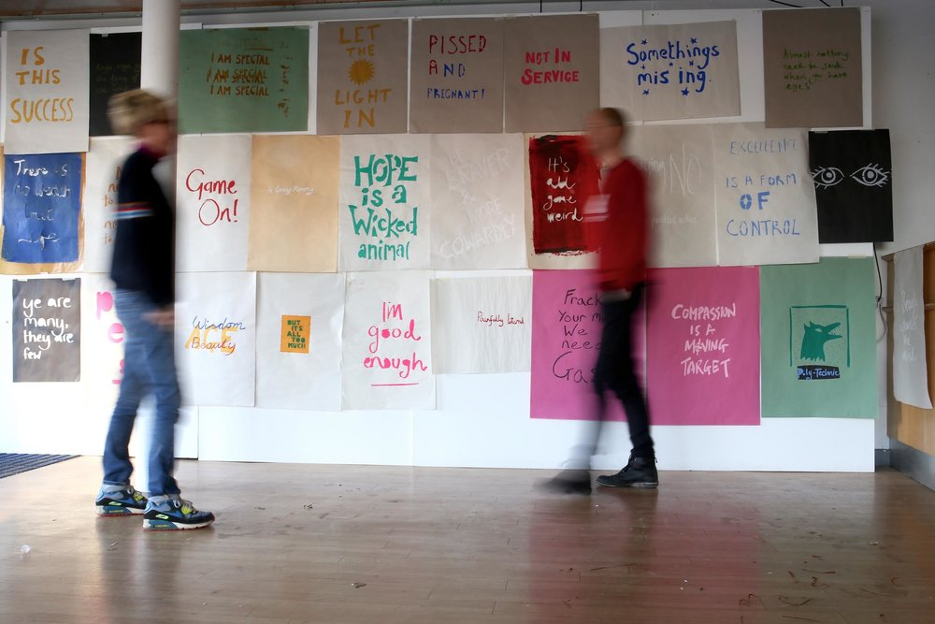YOU, ME, WE
*********************************************************************
Radical Print Workshop and Artist Talk
*********************************************************************
You Me We is an ever-growing mobile protest poster workshop and archive developed and kept by the Poly-Technic [aka Kate Genever and Steve Pool]. You, Me ,We, is an artwork - it is a radical screen-print workshop and an archive.

The workshop, together with its travelling exhibition, aims to encourage those involved to explore the questions around What is it to protest? Led by the Poly-Technic the sessions include thinking, talking, making, sharing. The archive holds examples of all screen-prints hand-made by people who had something to say. The archive is available as part of all activities.

Practically the Poly-Technic becomes resident at your site and participants are:
* Invited to develop and design a protest slogan relating to personal concern.
* Supported to cut stencils and print posters on provided papers.
* Encouraged to display poster alongside others in a pop up exhibition
* Included in You Me We archive kept by the Poly-Technic.
* Involved in a discussion around a pertinent relevant question.

We sometime use large-scale projections to showcase the work made.

****************************************************
The Poly-Technic, established in 2006, is the collaborative arts practice of Steve Pool and Kate Genever.

"With people in places, doing things"

Why Poly-Technic? Poly as in many and Technic as in techniques.

The Poly-Techic works in places – any place, creating opportunities for ourselves and others to come together to make, talk, think and learn. We stepped, back a few years ago and asked ourselves what can we do that's worth doing or rather - What can art do, that’s worth doing? In response, we decided to ask tough questions, critically think and open up 'active' spaces. To date these have included discussion groups, artist development, curated programs, radical print workshops, open call commissions and the production of work for exhibition.

You, Me, We began in 2014 after being commissioned to be ‘In Studio’ with Yr.6 Architecture students at The University of Sheffield. Since then it has gone on to set up and run week-long residencies as part of The Simple Stories They Tell Us Don’t Make Sense Anymore in Sheffield and Planet B Festival. Peterborough.

****************************************************
www.poly-technic.co.uk

