Maths Meets Arts Sandpit– Artist Open Call
The University of Leicester is inviting artists, through an open call, to send in expressions of interest for an Art-Science project. The project is funded by a University grant and is supported by the Wellcome Trust through the Public Engagement Scheme of the Institutional Strategic Support Fund. An artist project fee of £1000 is available to the successful artist.
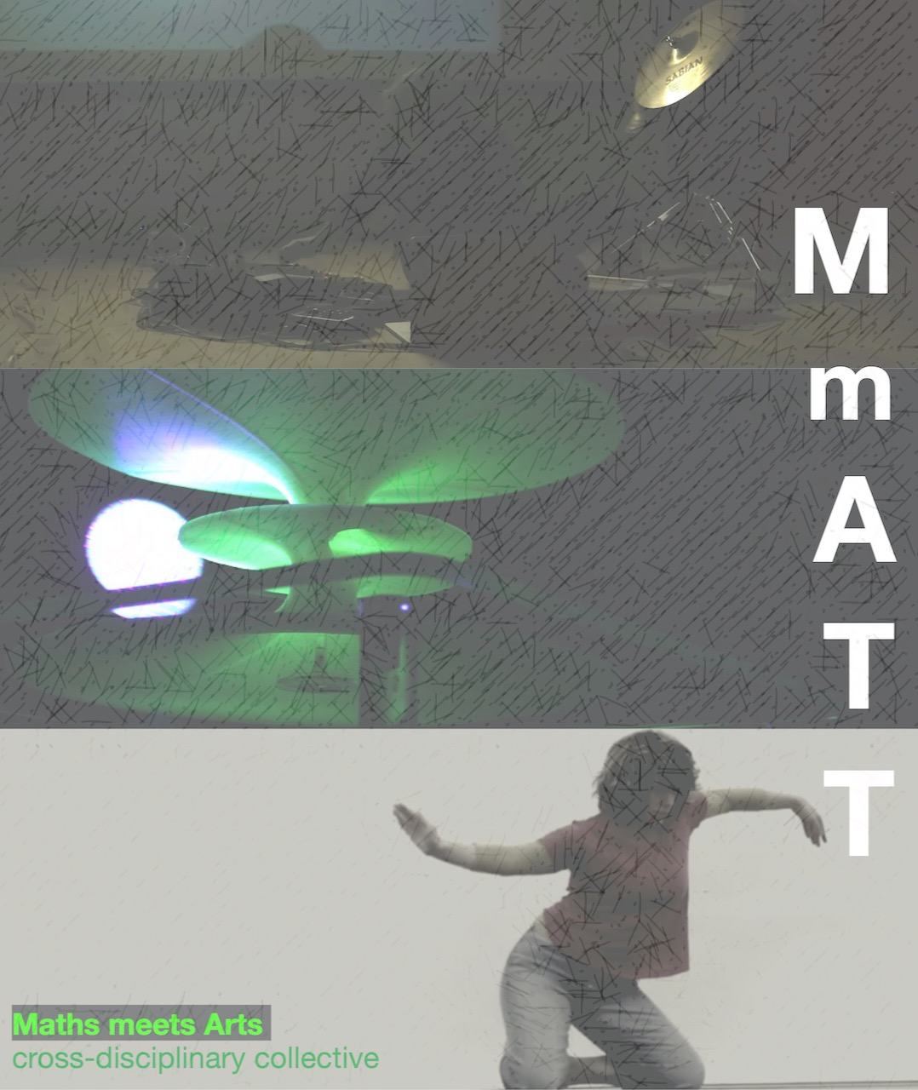
Following a pilot project last year, Dr Leschke, from the School of Mathematics, now leads an interdisciplinary “Maths meets Arts Tiger Team” of artists and researchers from the University of Leicester to investigate how the collaboration of artists and scientists can impact teaching, research and public engagement in science, and in particular, in mathematics. As part of these activities, there will be a facilitated networking “sandpit” event for artists and scientists to explore routes for collaborations. Through this process we hope to identify which project to support with the offer of the £1000 project fee.
The University of Leicester and the Wellcome Trust support this opportunity for artists to spend time exploring creative and collaborative practice within the context of current mathematical and related research. In particular, MmATT will support one art-science residency and commission between April and July 2020. Additionally, MmATT will support up to two joint projects by providing match funding for Arts Council applications.
Full Details
Similarly to the work of artists, research in mathematics may not have immediate and/or financial impact but its research is extremely relevant to science and society. The aim of the project is to investigate how modern research in mathematics, its beauty and its importance, can be communicated to a broader audience. In collaboration with Mathematicians and Artists we aim to find models for demonstrating how mathematicians in associated fields work, what problems they work on, which methods are used and what results they obtain. In some areas, computer graphics already allow to show images of work, however, the deeper beauty of mathematical object often appears for a mathematician from its context in mathematics: the question we want to address in this project is how to communicate this deeper understanding of mathematics to non-experts.
For this programme we are offering one art-science residency between April-July 2020. Additionally, we will support up to two Arts Council applications with match funding.
These opportunities are open to artists working in the following disciplines: Multi-art form, Crafts, Dance, Design, Film/TV, Visual Arts, Digital, Sound/Music, Performance, Storytelling, Poetry. Participating artists in the residency are being asked to produce new work that will be showcased at the “Maths Meets Arts Festival” in July 2020. Successful Arts Council funded projects are also expected to present outcomes at the festival. For our residencies we actively encourage a collaborative, discursive and open approach not only with the researchers, but also with each other. Participating artists should be prepared as part of the residency to present their work and ideas to scientists, students and academics within the University of Leicester as well as to public audiences.
Dates of residency: April – July 2020 (part-time)
Confirmed Outputs:
- Participation in the sandpit event to discuss science-arts projects and to develop a proposal for work for a shortlisted selection. Date: 26th February 2020, tentative time: 5:30-8pm.
- Collaborative work on science-arts project, April – July 2020, or application for Arts Council funding by Mid-March 2020.
- Maths Arts Festival: 11th-20th July, 2020.

Places available: support for up to three arts projects
Location: University of Leicester
Disciplines: Proposals are invited from creative practitioners working in any of the following creative disciplines: Multi-art form, Crafts, Dance, Design, Film/TV, Visual Arts, Digital, Sound/Music, Performance, Storytelling, Poetry
Expressions of Interest by: Sunday 23th February 2020
Selection Panel: Dr Katrin Leschke; MmATT.
Shortlist announcement and invitation to sandpit event, Tuesday 25th February 2020.
Sandpit – Wednesday 26th February 2020, 5:30-8pm.
Artist Proposals deadline: Sunday 8th March 2020
Final artist selected announcement: 13th March 2020
Maths Meets Arts Festival: 11th-20th July 2020, University of Leicester (venue TBC)

Budget
Project fee: Up to £1,000 for residency, up to £500 for match funding.
Materials budget: Up to £300 for residency.
Travel: small travel budget available (this will be worked out based on individual circumstances).
These can be spent either on or off site depending on the artists practice and work space required.

Selection Criteria:
For this micro-residency we are looking for applications from creative practitioners that demonstrate:
Essential
- a working practice in one or more of the outlined creative fields
- an interest in working collaboratively and within a scientific environment
- a passion for exploring art-science interdisciplinary practices
- a genuine interest in understanding and unravelling science research, science practices, science methodologies and/or the impact of science on society
- an interest in doing creative work within a scientific context
- a passion for engaging new audiences in creative activity
- that they are available to commit to the residency on a part-time basis over the project
Period: April – July 2020
Desirable
- formal training in art-form for which they are applying
- a track record to back up their proposal
- previous experience preparing work for exhibition
- previous experience in presenting and talking about their work to different audiences
- previous experience working/collaborating with non-arts professionals

Application Guidelines:
The aim of this micro-residency is to provide the space and time for artists to produce work that reflects their own practice and that focuses on science contents.
Please identify in your application how you might approach the themes in relation to your practice.
How to Apply:
Please submit an expression of interest of max 500 words, stating your interest in the project, your initial ideas if any, and any past projects that are relevant, please include up to 5 images or links to your work, and a current artist CV to kl96@le.ac.uk by 5pm on Sunday 23th February.

