Make.Practice.Perfect
The Collection, Lincoln
Friday 24th March

Contributor biographies

Andrew Bracey
Andrew Bracey is an artist based in Waddington, England. He studied fine art at Liverpool John Moores and Manchester Metropolitan Universities. He has exhibited extensively with solo exhibitions including Usher Gallery, Lincoln (2014/5); Nottingham Castle (2014/5), Manchester Art Gallery (2009); Transition Gallery, London (2007) and firstsite, Colchester (2006). Recent group exhibitions include Finding The Value (2014), York St. Mary’s; The Ends of Art (2013), Beton7, Athens; and Possession (I) (2013), BACC, Bangkok. Exhibitions he has curated include (detail) (2014/5) at H-Project Space, Bangkok and touring; Misdirect Movies (2013), Royal Standard, Liverpool, and touring; and Unspooling: Artists & Cinema (2010), Cornerhouse, Manchester. He is currently Programme Leader of MA Fine Art at The University of Lincoln, England.

Jessica Harby
Jessica Harby was born in Oak Lawn, Il, USA and studied at The School of the Art Institute of Chicago. Her practice encompasses drawing, installation, film and sound and mixes the delicate, the brutal, the absurd and the serious. Often using humour to address uncomfortable ideas, she has recently explored the importance of cows in the history of art galleries, the overblown masculinity of Arnold Schwarzenegger’s face, and why Donald Trump exists. Jessica is co-creator of the zine Tappa Tappa Tappa and is one of six artists chosen by Contemporary Visual Arts Network East Midlands for their two-year project Document.

Daniel Kelly
Daniel Sean Kelly is an artist and co-director of Two Queens gallery and studios, Leicester. Working largely in painting, printmaking and ceramics, he tries to create a speculative space for the imagining of other realities - a science fictional universe comprised only of objects existing in the world up to this point. He recently completed a short residency at Ekkisens gallery, Reykjavik and a solo exhibition at Trade Gallery, Nottingham. He is a current member of the free, alternative postgraduate programme 'The School of the Damned'.

Tracey Kershaw
Tracey Kershaw is a visual artist whose maternal experience is central to her practice. Her work is partly autobiographical, whilst at the same time reflecting on common experience. Working with photography, video, installation, sound and text, she explores issues of impermanence, fertility, ageing and the fragility of both time and relationships. She incorporates collaborative and participatory elements into her art; collecting, gathering and sourcing data from life, others and the world around her. She has exhibited widely, often integrating her own presence into her work.

Joanne Lee
Joanne Lee is Senior Lecturer in Graphic Design at Sheffield Hallam University. She is an artist, writer and publisher of thePam Flett Press, a serial publication essaying aspects of everyday life. The Pam Flett Press has appeared in PROGR-Fest, PROGR - Zentrum für Kulturproduktion, Bern, Switzerland; Offprint, Tate Modern and KALEID London, an exhibition showcasing the best books by European-based artists, as well as conferences such as Art, Politics and the Pamphleteer,Peoples History Museum, Salford. Her artistic research exploring place, photography and everyday objects has been presented in Art of the Edgelands, University of Exeter; Provocative Plastics, Arts University Bournemouth; Northern Light: Landscape Photography and Evocations of the North, Sheffield Hallam University; Perequian Geographies, University of Sheffield; Species of Spaces: A Transdisciplinary Conference on the Work of Georges Perec, Teesside University, from which an article is forthcoming in the journal Literary Geographies; as a chapter in Materiality and Popular Cuture: The Popular Life of Things (Routledge 2016); and in exhibitions including Green and Pleasant Land? Harris Museum and Art Gallery, Preston and In return, Sheffield Institute of Art Gallery.
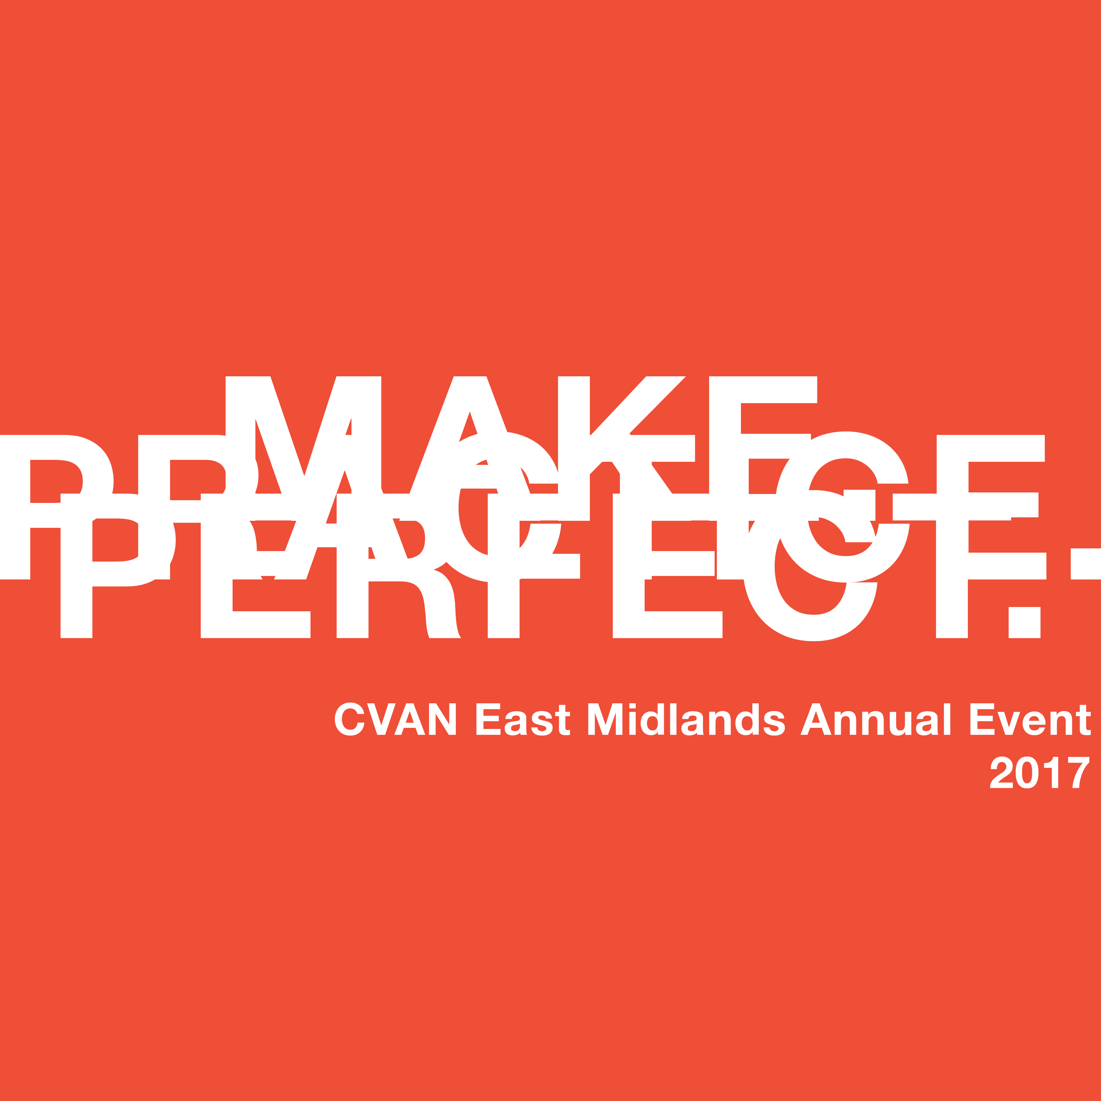

Geoff Litherland
Geoff Diego Litherland is a Mexican born artist based in Wirksworth, Derbyshire. Having spent his early years in Bolivia and Ecuador he moved to England and graduated from Falmouth College of Arts in 2002 with a first class honours degree in Fine Art Painting, in 2012 he completed an MFA in Fine Art at Goldsmiths University of London. He's currently a lecturer in Fine Art at Nottingham Trent University.

Conohar Scott
Dr. Conohar Scott is a lecturer in photographic theory and a practicing artist at the School of Media & Film, University of Lincoln. Conohar’s research interests include exploring the representation of environmental despoliation in photography and the application of art as a tool for environmental advocacy. As part of his artistic practice, Conohar founded the collective Environmental Resistance, which is currently comprised of an environmental scientist, a photographer and a graphic designer. The purpose of the collective is to raise awareness of industrial pollution and campaign for environmental remediation. Conohar also organises symposia under the banner ‘Network Ecologies: Exploring Relations Between Environmental Art, Science & Activism’.

Kajal Nisha Patel
Kajal is a visual artist, working between the UK and India. Having previously specialised in storytelling through documentary photography and filmmaking, she now works as a multidisciplinary artist, practising primarily with found saris and other vernacular objects. Her work includes themes such as imperialism, colonialism, patriarchy and the indignity of poverty. Interests in migration and human rights have led Kajal to research the marginalised experiences and multiple identities of British South Asian women. Through this work, she was awarded the 2016 Leverhulme Artist Residency within the department of Sociology, Media & Communication at the University of Leicester. She is consequently developing her research on South Asian women’s working and domestic lives, often through the lens of mother-daughter relationships. Kajal is the founder of Lightseekers social enterprise, which uses art, photography and storytelling as a participatory platform to learn about and engage with critical social issues.
​Lightseekers facilitates spaces for authentic storytelling to take place within diverse community settings.

Roma Piotrowska
Roma Piotrowska works as an Exhibitions Manager at Ikon Gallery. She also works as an independent curator, project manager, vlogger and writer. She worked on the development of Iraq Pavilions at the Venice Biennale in 2013 and 2015; and is the curatorial assistant of its upcoming edition at the 56th International Venice Biennale Art Exhibition. Previous roles have included working as a Curatorial Assistant for the 4th Guangzhou Triennial (2012, China). Her research interests focus around archives, memory, identity, politics and economy in relation to art.

Tim Shore
Tim Shore is a visual artist living in Derby, working with moving image, text, drawing and installation. He studied graphic design at Wolverhampton Polytechnic, and animation at the Royal College of Art, London. His practice explores the evidence and history of place and the narratives, stories and retellings that make a place known. His short films have been funded by Film London, Arts Council England and Channel 4 Wales. Thirteen (2016) commissioned by D-LAB (Digital Arts Derbyshire) a digital animation about time and space travel, which seeks to return the city of Derby to the centre of the Universe was exhibited at the Wirksworth Festival 2016. Also working in print, his artist books have been exhibited at PAGES, Leeds and Bank Street Arts, Sheffield. Tim is also Programme Leader of BA (Hons) Graphic Design at the University of Derby.

Mark Smith
Mark Smith is Executive Director of Axisweb, an independent charity, platform and network supporting the development and showcasing of contemporary art. As Director, Mark is responsible for leading and shaping the organisation’s future development. As a digital producer Mark has led and collaborated on the development of art based digital programmes, apps, websites and installations with organisations such as Mozilla Foundation, Art in Yorkshire, The Baltic, Crafts Council and Great Ormond Street Hospital. Starting in May 2017, in partnership with Manchester School of Art, Mark is heading a two year action research project exploring models of validation for artistic practice outside conventional gallery or museum settings.

